Title or Task: | Multimedia  
Description: | Technology Process Chart and Poster

Files Required
Suitable for Classes: | Multimedia / Digital Media or Design
Area: | Technology & Enterprise
Teacher: | Mr Peter Faulks
Marks: | Worth: 20% | Weighting: 20%
Date Due: | Late penalty 5 marks plus 2 marks per day thereafter

Task Brief:
Outcomes: | Investigation : Devising : Producing : Evaluating

Items highlighted in yellow are tasks for you to complete
Items in Purple are help tips

UNIT: Multimedia
TASK 1: Technology Process & Poster (100 marks)
Task
8
You will need a file for his class, with inserts create a cover page with your name and picture on it (Use you photo from the nameplates lesson).

Task 1 Technology Process Chart and Poster
Chart - Using Inspiration create a diagram that covers the Technology Process for Multimedia

Poster Create a poster advertising the Technology Process

See end of document for an explanation of the technology Process

There are 4 parts to this task:
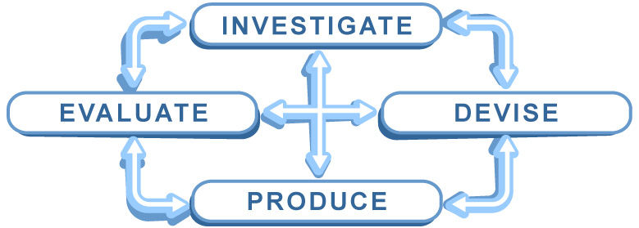

- Investigate: The contents of the Technology Process
- Find definitions of Investigate, Devise, Produce & Evaluate

- Devise: Sketch and plan your layout
- On A4 plain paper sketch a “Technology Process” chart using diagrams, text and colour.

- Annotate your designs

- Produce: Create a chart in Inspiration or Illustrator of the Technology Process
- Create a concept chart using Inspiration on the computer to produce your chart from your sketch or diagram.

- Using Photoshop create an A3 poster that covers the Technology Process for AIT or Multimedia

- The poster should be exciting and include graphics or images, large text and supplementary details of the elements of the Technology Process.

- Evaluate: Evaluate your efforts
- Provide evidence of your work

- Complete the Product, Process and Self evaluations

What needs to be in your portfolio for assessment?
- Evidence of your investigation (notes, bibliography, brainstorm
- Your detailed report which is one document containing:
- Inspiration Chart as cover page
- graphics inserted
- clear use of font
- neatly formatted.
- Your evaluation must demonstrate research, show depth and explore options by covering the following content in detail:
- technical specification for poster.
- a timeline of planning implementing.

Marking Grid Chart & Poster
The Technology Process (Concept diagram) 100 Marks

Item Assessment Sheet | Possible  Mark | Actual  Mark
Investigating The contents of the Technology Process  - Find definitions of Investigate, Devise, Produce & Evaluate | 10
Devise Sketch and plan your layout  - On A4 plain paper sketch a “Technology Process” chart using diagrams, text and colour. Depth of Research | 10
- Annotate your designs | 5
- Apply a graphic context or theme to the process | 5
Producing Create a chart in Inspiration of the Technology Process  - Create a concept chart using Inspiration on the computer to produce your chart from your chosen design  - Using Inspiration create an A4 poster that covers the Technology Process for Multimedia (QUALITY) | 10
- The poster should be exciting and based upon a theme | 10
- Including graphics or images, large text and supplementary details of the elements of the Technology Process. | 10
Create a poster  - One A1 document from 4 A4 templates Using Photoshop create an A3 poster that covers the Technology Process for Multimedia (QUALITY) Use of Colour  - The poster should be exciting and based upon a theme | 10
- Including graphics or images, large text and supplementary details of the elements of the Technology Process.  Graphics inserted, Font or Good use of Boxes, Formatting Use of Images | 10
Evaluation Evaluate your efforts  - Provide evidence of your work in the form of a PPT Portfolio  - Complete the Product, Process and Self evaluations | 10  10
Total | 100

Teacher Comment:

Complete on Line and Print this out

- Take a screen shot of your Inspiration chart (Press Prt Scr Button on the keyboard)

- Open MS Word and Click on Edit Paste or Ctrl V or Right mouse Paste

- Crop the image to show just your chart and add the following evaluation

Evaluation Individual Task
Copy to a new sheet and complete the form

Multimedia Task1 – Creating a chart and poster

- Provide evidence of your work done:
- Scan your hand drawn designs and insert as jpeg images
- Take a screen shot of your Inspiration chart
- Save your poster as a jpeg and insert into you Task Portfolio

- Complete the Product evaluation

- Complete the Process evaluation

- Complete the Self evaluation

Devising
How did you plan your design – Storyboard, Brainstorm, Notes, Sketches, Just did it, other?
What did you do?
How did you do it?
Why

Investigating
What did you read or look up?
What did you do?
How did you do it?
Why

Producing
What software did you use? Did you use graphics, boxes, objects, clip art?

What did you do?
How did you do it?
Why

Evaluating
Have you completed this evaluation form and rated yourself? Yes/No
Product evaluation, I could improve my final product by:

What skills have you learnt?
How do you rate yourself? 1 – 10 (Excellent)
No (Low) Undecided Yes (High)
Rate yourself in the appropriate box: | 1 | 2 | 3 | 4 | 5 | 6 | 7 | 8 | 9 | 10
I found this task interesting
I have worked hard on this task
I have understood the task requirements
I enjoyed working on the task
I had enough time to complete the task
I had all the skills required to complete the task
I am happy with my finished product
I found it easy to find the information I required

Did you enjoy this task
Suggestions

Samples below:

Task 1 : Technology Process Chart sketch
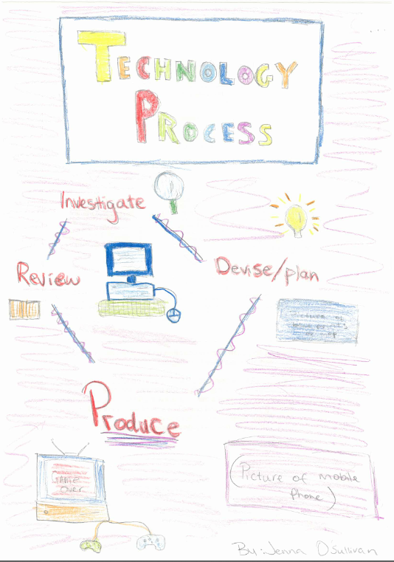

Sample Inspiration
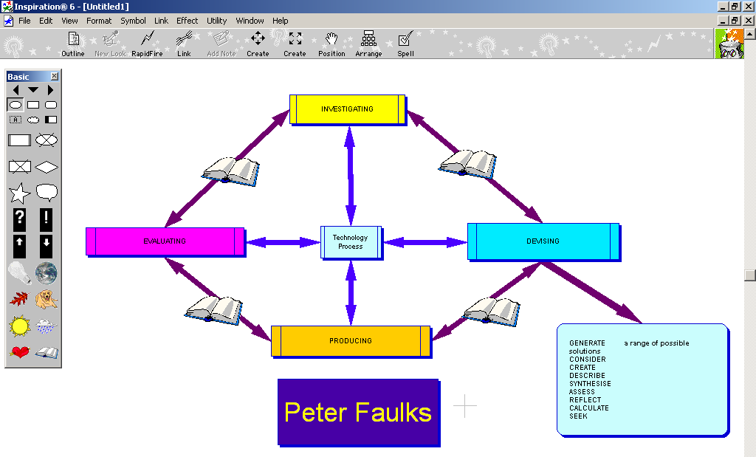
Sample 2

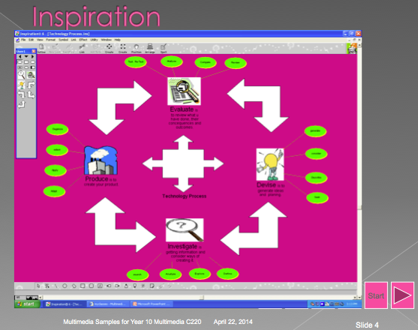

Sample Poster 4 Four A4 Pages combined to 1 Poster

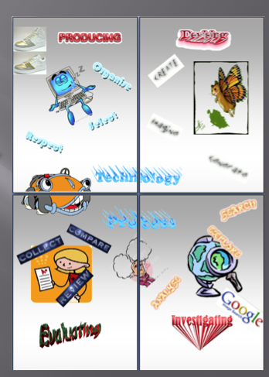

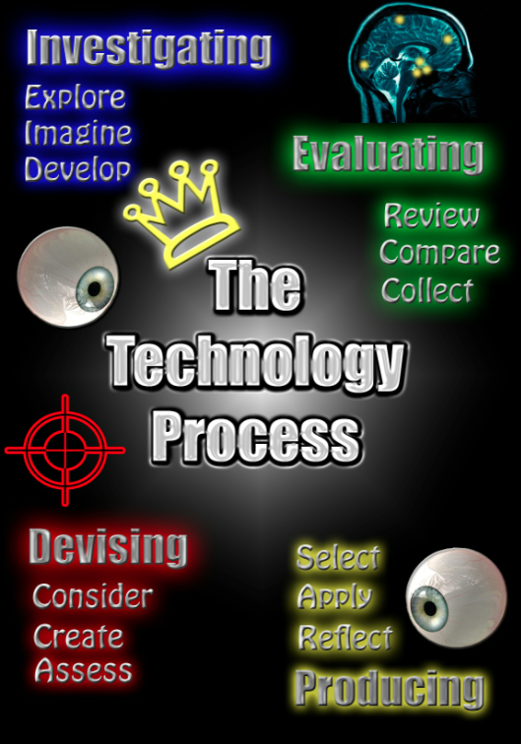
Useful notes follow:
The Technology Process

What is the technology process?
The technology process is a range of strategies that you use to develop your thinking skills. It’s thinking about the way that you think. Thinking skills include the way that you dream up ideas and concepts, how you create and make things. It can also include ways that you discover information, solve problems and evaluate solutions.
The technology process has four main steps which are interlinked.

When you apply the process, you might start at any one of the four aspects and jump between them. There is no set order in which to work.
For example if you wanted to redesign an existing product for a new market, you might begin with an Evaluation of the existing product.
If you needed help planning your work, then you might start with an Investigation and move to Devising to plan your time and bring your ideas to life.

Why use the technology process?
The technology process can help you develop techniques to improve the way you think and work. This can be achieved by completing some specialised activities.

For example, if you can’t think of new ideas, you could use a technique called brainstorming. Once you have some ideas, you may not know where to begin working out what to do with them. In this case, a plan can be developed using a storyboard.

A brainstorm and a storyboard are tools which help you express how you think.

It is not always obvious to your teachers or classmates how you have generated your ideas, what path you intend to follow or how you decided what was good work and what was bad. Using the thinking tools as part of the technology process is the easiest way to demonstrate your thinking. Including your tools in your Portfolio helps your teacher to assess your progress.

Where to begin?
To successfully complete any of your activities or tasks and to use your time effectively, you need to ensure that you fully understand what you are required to do. You should always ask yourself:

What do I have to do?

If you can explain in your own words what needs to be done, you will demonstrate that you have a good understanding of the activity or task.

Technology Process Explained

“INVESTIGATION”

Investigate
Students explore the form of products and their everyday use by giving sensory focus to their investigation: for example, they touch or rotate objects to help observe the features of an object and they move or rotate objects and equipment to explore their uses. They attend and respond to materials, resources and processes from their everyday experiences: for example, they may show curiosity toward new resources or anticipate the outcome of a cooking process. Through imitating others or by trial and error, they use products for their intended purpose, such as using a wooden spoon to stir a mixture or glue to connect paper. They also improvise and use familiar products in creative ways, such as plastic cups to build a structure or a pencil as a rolling pin. Through exploring and using products they may develop the basic skills to cut, paste, attach, roll, press or pinch.

Is finding information, identifying opportunities and considering implications of creating products

ANALYSE the set criteria of the Design Brief
EXPLORE the options allowed by the Design Brief
DEFINE a focus for your investigation
SEARCH databases for ideas (eg: Internet, books, etc)
REVIEW “historical” data; learn from trials of others
REALITY CHECK – equipment, materials, timeframe
DETERMINE constraints and limitations
IMAGINE creative alternatives
DEVELOP a profile of the audience/client
ASSESS the potential impact to society

“PRODUCING”

Produce
Students participate in production processes: for example, they may indicate a picture of interest in a magazine and help to tear out or cut and glue the picture to a birthday card they make for a friend. They follow procedures and step-by-step instructions and use tools for their intended purpose: for example, they press a switch to turn on a microwave oven, press on keys to enter information into a computer, or use sand paper to sand a wooden item. They begin to organise their own actions into a process by following pictures or visual cues: for example, they sequence a set of photographs of popcorn being prepared, or a wooden toy being made, and are able to follow the sequence to repeat the activity with support.

Is organising and managing the creation of creation of your design solution in a work environment

ORGANISE a system to achieve goals
NEGOTIATE use of shared equipment
AQUIRE new skills if you need them
SELECT the “tools” for optimum results
APPLY your skills to the best of your ability – aim high!
ADAPT & ADJUST to unexpected problems
COMMUNICATE clearly to collaborate effectively
MENTOR/ASSIST if peers need a little help
REFLECT on your progress every session – “Journal”
RESPECT safety procedures at all times

“DEVISING”

Devise
Students indicate their ideas, such as choosing from a given selection when developing a solution for creating a technology: for example, when generating ideas for a snack, they select bread to put in a toaster and choose a knife instead of a fork to spread the topping. They use vocalisations or gestures to select from options provided: for example, they point, nod, speak, pick up or use facial expressions to accept or reject items. When asked or prompted, they indicate their preferred method for an activity or material, appropriate item or action for a specific purpose.

Is the process of generating ideas and creating plans and proposals for solving design issues.

GENERATE a range of possible solutions
CONSIDER your client/audience/market and their needs
CREATE a written proposal, clarifying your intention
DESCRIBE the materials, tools, equipment, you will need
SYNTHESISE plans, sketches, storyboards, technical drawings, recipes, patterns, layouts, electronic drafts
ASSESS how they address Design Brief specifications
REFLECT on the skills you will need
CALCULATE expected costs & quantities
SEEK group members with necessary skills

“EVALUATING”

Evaluate
Students express feelings about the processes they used and the product they have made: for example, they use structured choice-making to show the objects they liked to use and point to pictographs or photographs of the activity they did or did not like; communicate through vocalisations or gestures their feelings about the toast they made and ate, or a birthday card they created to give to a friend. They communicate their responses to an experience in individual ways, such as using vocalisations or gestures to request repetition of particular parts of the process. They express their emotions and judgements about the product: for example, they point to a picture of a smiling face or do not eat the food they cooked. They begin to answer questions about the features of a finished product: for example, they nod when asked if their card is a certain colour or verbalise the name of the material used to make a model

